**Chinese Day at Leeds Metropolitan University**

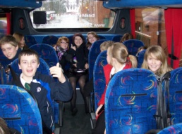

A group of 23 Year 8 pupils spent the day at Leeds Metropolitan University on Friday 26th February with three others regional secondary schools where they learned a little bit of Chinese as well as a glimpse into Chinese culture.

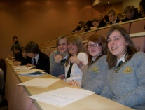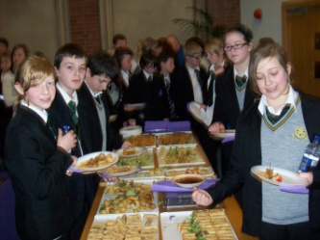The day started with pupils having to write about their personal experiences in languages or different cultures in the hope that their work will be published in a book being produced by the university about Language Learning.

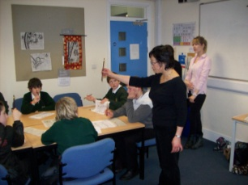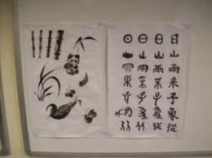After a Chinese themed lunch of spring rolls, dimsum, prawn toast and prawn tempura, the pupils split into two groups and participated in four workshops throughout the afternoon. The pupils learned how to do Chinese calligraphy and each received their names written in Chinese. In addition, they took part in a paper cutting activity, learned some Chinese and went on a virtual tour of China.

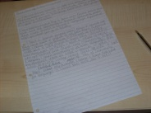Mrs Otterburn commented that the group as a whole participated really well in all the activities and everyone seemed to have a really enjoyable day. In addition to the Chinese activities, the pupils got a taste of life at University and hopefully this will inspire them to continue on to further studies in the future. Their behaviour was impeccable and they were a real credit to themselves and to Trinity.

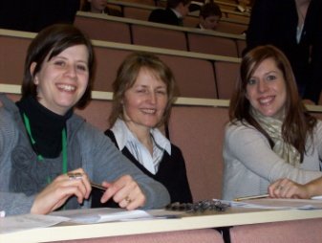Mrs Otterburn would also like to thank Miss Hollis, Mr Helliwell and Mrs Jones for accompanying the group and making the trip a memorable one!